CSCI 221 Computer Programming II

Assignment 5

- Your entire project folder needs to be zipped up (only .zip files accepted!) in one file and uploaded to OAKS before the deadline. Demo project on Final Exam Night.
- Thanks to Sebastian van Delden, the original author of this assignment.

Let’s Play Ball… Again.. ☺

You need to implement the following UML.
Player

- PlayerID: String
- FirstName: String
- LastName: String
- BirthDate: String
- BirthLocation; String
- Height: int
- Weight: int

+toString, get and set methods, constructor
<<interface>>
Comparable

+compareTo(object): int



*
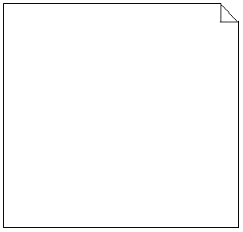
Constructor reads in the three text files and stores Batter and Pitcher objects in the ArrayList.

Pitcher

- YearID: int
- TeamID: String
- Wins: int
- Losses: int
- ERA: double

+constructor(s), toString, get and set methods
Batter

- YearID: int
- TeamID: String
- HomeRuns: int
- RBI: int

+constructor(s), toString, get and set methods

PlayerStatsPortal

+main(String args[ ]): void
Players

-Roster: ArrayList<Player>

+Players(String PitData, String BatData, String MasterData)
+toString,
+getTopBattersSorted(int n): ArrayList<Batter>
+getTopPitchersSorted(int n): ArrayList<Pitcher>
+getPlayer(String PlayerID): Player
+getTopHomerunHittersSorted(int n): ArrayList<Batter>
+getLowestERASorted(int n): ArrayList<Pitcher>

The main method provides a user interface via the console. Like the previous assignment, the interface should test the methods in Batters and Pitchers.

Data is located in Master.csv, Batting.csv, and Pitching.csv
Batter compareTo:
If RBI is tied,object with highest HomeRuns.is better
Else object highest RBIs is better

Pitcher compareTo:
If wins minus losses tied, object lowest ERA is better)
Else object with highest wins-losses is better

(return -1, 1, or 0)

